1. Problem Statement

1.1. Background of the problem
According to UNDRR, globally nearly ’70 million people are exposed to flood risk each year’. Vietnam is one of the most disaster-prone countries in the world (WHO, 2021b). Due to a 3440km coastline and a diverse and complex topography, the country experiences numerous natural hazards (or disasters). One of the disasters is flooding - approximately 70% of the population in Vietnam who live in coastal areas and low-lying deltas are exposed to the detrimental risk of flooding. Over the past 10 years, 80-90% of all documented disasters have resulted from droughts, heat waves, floods, tropical cyclones, and severe storms (the latter 3 all are associated with flooding). Over the past 20 years, the central provinces of Vietnam, namely Quang Binh and Quang Tri (the most vulnerable region to flooding in comparison to other regions) have endured approximately 70% of the damage (nationwide) caused by flooding and storms (Asian Disaster Reduction Centre). Therefore, the problem investigated is flooding, with Vietnam as the selected area of study.

1.1.1. What are floods?
An ‘overflow of water that submerges land that is usually dry (Earth Networks, 2021). Floods have been identified as the most frequent type of natural disaster (WHO, 2021) and the ‘most widespread of all weather-related natural disasters’ (The National Severe Storms Laboratory, 2021). Different types of floods occur in coastal and inland locations. Although there are various types of floods, most are caused by excessive rainfall, the overflowing of rivers, storm surges and tsunamis, broken dams, channels with steep banks, insufficient vegetation and accelerated snow/ice melt (WHO, 2021a).

1.1.2. Types of floods
Coastal flood: the overwhelming influx of seawater onto ordinarily dry land areas along the coast. River flood: when water levels rise above the top of riverbanks. It occurs in all river and stream channels.
Storm surges: a severely dangerous form of flooding as it can flood substantial coastal areas simultaneously. They occur because of meteorological storms (e.g., windstorms, hurricanes, tornadoes) that cause higher than normal tides on the coast.
Inland flooding (also referred to as Urban flooding): rainfall is the most common cause - either by constant and steady rainfall over several days or by an intense fleeting period of rainfall.
Flash Floods: occur almost anywhere as a result of short intense bursts of rainfall/severe thunderstorms that last 6 hours or less. Consequently, they are classified as one of the most dangerous forms of flooding. (Australian Institute for Disaster Resilience, 2021).

1.1.3. Impact of floods
The damage and impact of floods is varied, significant and vast. Devastating effects include loss of life (75% of deaths in flooding are due to drowning and fires caused by flooding), property damage (e.g. destruction of crops and loss of livestock, displaced homes, food/water supplies, disrupted health systems and facilities), economic impacts (as a result of damage and disruption to roads, bridges, power plants, etc – causing holds on business activities), psychosocial impacts (emotional distress, physical health illnesses from waterborne diseases such as cholera and typhoid) (WHO, 2021b).

1.2. Floods in Vietnam
Vietnam is exposed to all the types of floods that cause ‘severe economic losses, damage to infrastructure and loss of life’ (Nguyen et al., 2021). A long coastline coupled with highly concentrated populations and economic assets located at river deltas and other low-lying areas makes flooding a main hazard in Vietnam as they are exposed to storm surges, high rising sea-levels, and typhoons.
According to Garschagen (2016), solutions provided are lacking as a result of ‘challenges in the implementation of decentralisation of flood risk management due to local capacities and resources’ and ‘lack of stakeholder participation in the planning and implementation of potential risk reduction and adaptation options.’ Tried and tested solutions over the years include infrastructure building (dike systems), awareness raising (training courses on how to adapt to urban flooding) and improved drainage systems. Evidence highlighting the lack of practicality and impact of the forementioned solutions are emphasised with the most recent floods in Vietnam. In October (2020) alone, floods resulted in 511,172 submerged houses, 3,429 collapsed houses, 333,084 damaged houses/roofs blown away (International Federation of Red Cross and Red Crescent Societies, 2021).
The solution provided below is not only practical, but it will mitigate the numerous dire effects and impacts associated with flooding.
2. Solution Development & Implementation

2.1 Solution Development
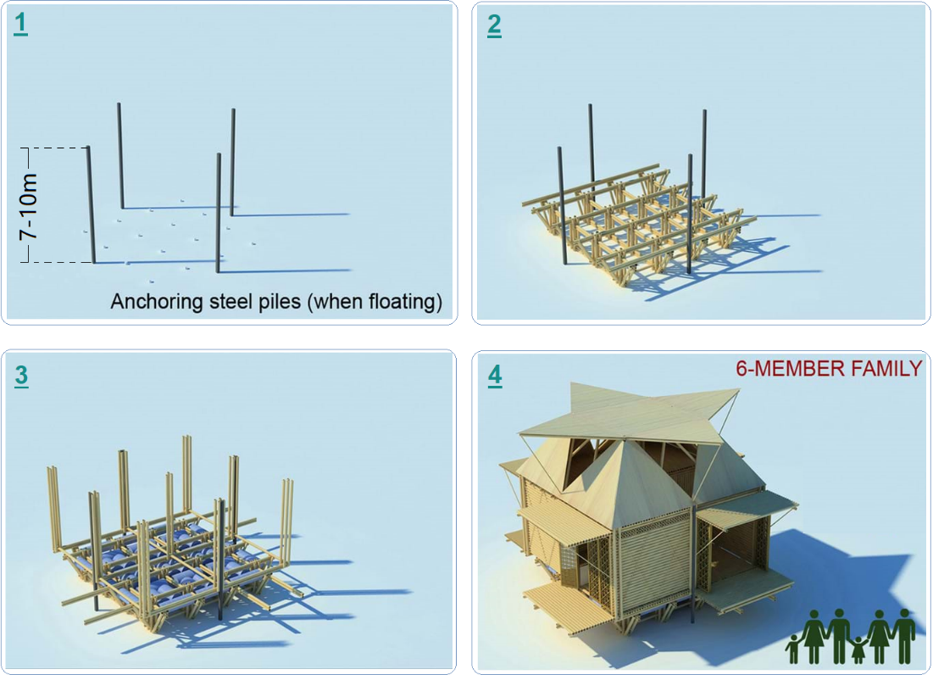
Figure 1: A design of the floating house
Due to the seasonal floods that occur every year and which cause many people to leave their flood-hit and damaged houses and evacuate to a higher ground, our team generated an innovative solution, namely “The Floating House” (Figure 1). In terms of structure, this disaster-proof shelter is attached to four anchoring steel piles which fix the whole structure into one place. These anchoring steel piles can be seven- to ten-metres long, depending on the location, because the water level of floods rise in each region differently. Next, the base of the house will be built, and this creates the ground floor. In general, the floor dimension is 5mx6m which will cover a total space of 30 square metres. Then, multiple emptied plastic barrels will be tied up underneath the ground floor. These recycled drums are not only accessible everywhere across the country but also easy to maintain and cost saving. Perhaps, they are the most important building materials because they enable the whole property to float when floods come, and everything is suddenly surrounded with water. Finally, the walls and the roof are constructed using galvanised metal sheets. Like plastic barrels, this type of construction material is conveniently available and inexpensive.

2.2 Feasibility Study

2.2.1 The Economic aspect
The overall cost is approximately 1300 USD to 1500 USD, equivalent to 30m – 34m VND, including material cost and labour cost. This is considered as affordable for most Vietnamese citizens since the GDP per capita of Vietnam is US$2,785.7, as of 2020 (The World Bank Group, 2020). The whole construction is estimated to be fully built within 3-5 working days with 3 skilled builders. Most importantly, there is no architect required as the design is straightforward, easy to follow, and manageable for experienced workers.

2.2.2 The Sustainable aspect
The Floating House is sustainable in many ways. First, it is environmentally friendly. While 100 percent of building materials possess no harm to the surrounding environment, most of them arrive from recycled resources and are easily obtainable, such as the plastic drums. Second, the shelter is long lasting for up to 25 years. For instance, the galvanised sheet metal is water resistant and anti-termite which strengthen the lifespan of the house. Unlike temporary settlements, this house simultaneously aims for long-term recovery and emergency relief. Third, it is applicable worldwide, especially in developing countries. The low-cost and simple-designed standards aim to transfer the idea to other parts of the world where floods are the most common disaster.

2.2.3 The Resilience aspect
Our product is more than a tent. To begin with, it automatically levitates when floods approach and descends when the water level declines because of the empty barrels. The whole unit can save the lives of 6 people including 4 adults and 2 children. In addition, this people-centred approach increases the disaster preparedness among communities by pre-stocking all the humanitarian essentials needed, such as water, sanitation, foods, and medicines. Statistically, the average duration of floods is 9.5 days. If a 500-litre water tank is installed on the roof, The Floating House can help a six-member family to be isolated in it for at least 21 days while waiting for rescuers or water level to decline. Other from that, this flood-resistant house can be utilised as a storage unit in normal days.

2.3 Implementation
Our flood-proof home falls into the preparedness stage within the disaster management cycle since the central provinces of Vietnam are annually exposed to floods. Some rural areas in particular, experience flooding three to four times a year, and each time flood water either destroys their belongings or carries off every home tool. Our idea encourages villagers to build The Floating House next to their daily typical house so that when the storms come, they can upload their valuable objects into the unit and ensure the effectiveness of their disaster response.
Considering all the facts, we’ve created two designs to fulfil the needs of a broader community. The first concept is a 30 sqm unit which includes 2 bedrooms, one cooking area, a 500-litre water tank, and it can save up to 6 people. The second prototype is a 50 sqm unit whose facilities consist of 3 bedrooms, one kitchen, and a 1000-litre water tank. Since the family culture of Vietnam is patriarchal and patrilocal where two to three generations share the same roof, the latter design is undoubtedly suitable for the majority of local households.
Our group members have queried building merchants in Vietnam to ensure the accurateness of our production costs. In general, our floating house includes three main components: the plastic barrels, the galvanised metal sheets, and four anchoring steel piles. First, 50 200-litre barrels are needed to support 8,150 kg of buoyancy. These reusable barrels which cost 80,000vnd each, will be accounted for 4,000,000vnd in total. Second, the price of metal sheets is 70,000vnd per sqm and a total of 140sqm required will be valued at about 9,800,000vnd. Third, the four steel piles are the most expensive material, and their price is at 12,600,000vnd. With a 120-hour labour cost of 4,440,000vnd and other operational costs, an estimated quotation of a 30 sqm unit will be approximately 32,000,000vnd and equivalent to US$1,400.

References
Asian Disaster Reduction Centre. Coping with century flood disasters in central Vietnam. https://www.adrc.asia/management/VNM/vietnam_response_to_disaster.html?Frame=yes
Australian Institute for Disaster Resilience. (2021). Flood. https://knowledge.aidr.org.au/resources/flood/
Davies, R. (2021). Vietnam. https://floodlist.com/tag/vietnam
Earth Networks. (2021). Flooding 101. https://www.earthnetworks.com/flooding/#flood-type
International Federation of Red Cross and Red Crescent Societies. (2021). Vietnam: Floods - revised appeal n° MDRVN020. (). https://reliefweb.int/report/viet-nam/vietnam-floods-revised-appeal-n-mdrvn020
Natural Disasters Association. (2017). Natural hazards. https://www.n-d-a.org/flooding.php
Nguyen, M. T., Sebesvari, Z., Souvignet, M., Bachofer, F., Braun, A., Garschagen, M., Schinkel, U., Yang, L. E., Nguyen, L. H. K., Hochschild, V., Assmann, A., & Hagenlocher, M. (2021). Understanding and assessing flood risk in Vietnam: Current status, persisting gaps, and future directions. Journal of Flood Risk Management, 14(2), e12689. https://doi.org/https://doi.org/10.1111/jfr3.12689
Nunez, C. (2015). Floods, explained. https://www.nationalgeographic.com/environment/article/floods
The National Severe Storms Laboratory. (2021). Severe weather. https://www.nssl.noaa.gov/education/svrwx101/floods/
WHO. (2021a). Disaster in Viet Nam
. https://www.who.int/vietnam/health-topics/disasters
WHO. (2021b). Floods. https://www.who.int/vietnam/health-topics/disasters
The World Bank Group. (2020). GDP per capita (current US$) - Vietnam. https://data.worldbank.org/indicator/NY.GDP.PCAP.CD?locations=VN

